METHODS – or INTRODUCTION?

*Study area and sampling:*

Wide coverage, over multiple biomes, varying almost independently in temp and precip (Fig 1a-c)

**1.) Quantifying leaf proteins at the continental scale.** A total of 324 photosynthetically active Eucalypt leaf samples were collected from 32 species; four species were recorded at multiple location. For each species-location combination, three canopy leaves were collected from each of three individuals to make a total of nine samples.

a.) Sampling locations (triangles) were located along three latitudinal bands, spanning broad gradients of rainfall and temperature. The resulting coverage of climate space represents of much of the vegetated area of the Australian continent;

b.) Sampling locations lie within six of the eight biomes described by Whittaker (1967).

c.) Mean annual temperature (oC) and mean annual precipitation (mm, log scaled) of sampling sites (triangles) are distributed orthogonally with respect to one another (r = ).

RESULTS

*Protein composition of the average eucalypt leaf.*

In Fig 2a we show how protein resources are allocated to all major functions in an ‘average’ eucalypt leaf (based on 320 leaf samples). The majority (64%, SD X%) of protein was associated with photosynthesis; 36% was associated with the carbon fixing Calvin Cycle and 22% (SD X%) with the light reactions (Fig 2a). The most abundant individual protein complexes were Rubisco, comprising 30% (SD X%) of leaf protein, and photosystem II (X%, SD X%) (Fig 2b). Protein synthesis, folding and degradation was the second most abundant top-level category at X% (SD X%) (Fig 2a).

Our mass spectrometry approach allowed detection of X individual proteins per sample, on average. These proteins accounted for 99.9% of sample mass, among which the top 500 most abundant proteins represented 90% (Fig 2c). This is a higher degree of dominance by the top few proteins than observed in [comparison] (Fig 2d), reflecting the specialist nature of leaves as photosynthetic organs.

*Linking leaf protein abundances with environment and functional traits*

We were able to describe patterns of leaf protein abundance across environmental gradients, as well as in relation to key leaf functional traits and physiological properties (Fig 3a). Per leaf area abundances of all major protein functional categories were cross-correlated with each other, as well as with leaf nitrogen per area (N\_area), leaf mass per area (LMA), and maximum photosynthetic rate (Amax). Patterns in proportional abundances of protein functional categories (indicating investment in a defined function relative to investment in all other functions) were considerably less general.

*b.) first scatterplot panel*

We selected several relationships of interest to the vegetation modelling community for deeper analysis; to date these relationships have only been investigated via proxies.

We found a notable reduction in Calvin cycle proteins per leaf area in response to MAT (stat, Fig. 3b-i), and to a lesser extent MAP (Fig. 3b-iii). Proportional allocation of protein resources to Calvin cycle protein did not adjust over gradients of MAP or MAT (Fig. 3b-ii,iv) but increased marginally (stat) with increasing incident radiation (Fig. 32b-vi). Calvin cycle protein abundance was highly correlated with total protein abundance (Pearson’s r = 0.97), and environmental trends in Calvin cycle protein abundance were essentially identical to trends in leaf protein abundance.

Pronounced declines in both per leaf area and proportional photosystem protein abundance were apparent with incident irradiance (Fig. 3b-v, X% ; (Fig. 2b-vi), X%). No per leaf area response to MAP was observed (Fig. 3b-iii), although proportional abundance of photosystem proteins increased strongly with increasing MAP (Fig. 3b-iv). MAP and incident irradiance are correlated (i.e. denser canopies at wetter sites, Pearson’s r = -0.59) and it is likely that the MAP response of photosystem protein abundance is driven by changing light conditions. Per leaf area photosystem protein abundance was strongly correlated with total leaf protein abundance (Pearson’s r = 0.82) and declined substantially with increasing MAT (Fig. 3b-i).

The range of interspecific variation in photosystem protein proportional abundance (0.09-0.23, 2.6-fold) was considerably higher than for Calvin cycle proteins (0.30-0.39, 1.3-fold). Thus eucalypt leaves specifically optimised protein allocation to light capture in response to environmental conditions (some stats and numbers), while adjustment of carboxylation capacity was largely achieved through bulk changes in per leaf area protein content.

*c.) second scatterplot panel*

One obvious way Calvin Cycle protein per leaf area can change is via changes in depth of mesophyll and of leaf, and indeed adjustments in per leaf area Calvin cycle protein abundance occurred to some extent via changes in leaf mass per area (LMA) (Fig. 3c-i). However the substantial scatter around the Calvin cycle – LMA relationship indicating that LMA responded to other requirements as well as to carboxylation capacity. Photosystem abundance did not increase per leaf area with increasing LMA (Fig. 3c-ii) and declined as a proportion of total leaf protein. Leaf light harvesting capacity thus appears to be optimised for a given leaf area independently from leaf thickness.

Leaf nitrogen per area was a strong predictor of both Calvin cycle and photosystem protein abundance per leaf area, and no relative changes in these protein categories occurred with increasing nitrogen per area.

*d.) protein abundance/concentration/LMA multiple regressions*

We hypothesised that Calvin cycle protein abundance would be driven by temperature dependence of enzyme kinetics, and maximisation of CO2 drawdown at low stomatal conductance in water-limited environments. Fig 3d-i shows that these demands were in fact complementary: leaves at cold dry sites required the most protein. More Calvin cycle protein per leaf area was associated with higher photosynthetic water-use efficiency (Fig 3e), providing corroborating evidence for the CO2 drawdown hypothesis. Leaves at warm wet sites experienced neither constraint, having low protein content per area and low LMA.

The role of LMA versus leaf protein concentration (protein as a fraction of leaf dry mass) in determining per leaf area protein abundance depended interactively on MAP and MAT (Fig 3d-ii,iii). Low per leaf area protein abundance at warm, wet sites was more closely associated with low LMA than low protein concentration, while high per leaf area protein abundance at cold, dry sites was strongly associated with high protein concentration.

Extras:

Photosynthetic WUE isn’t related to LMA and is more strongly related to Calvin cycle protein per leaf area **(R2 = 0.28)** than total protein per leaf area (R2 = 0.20).

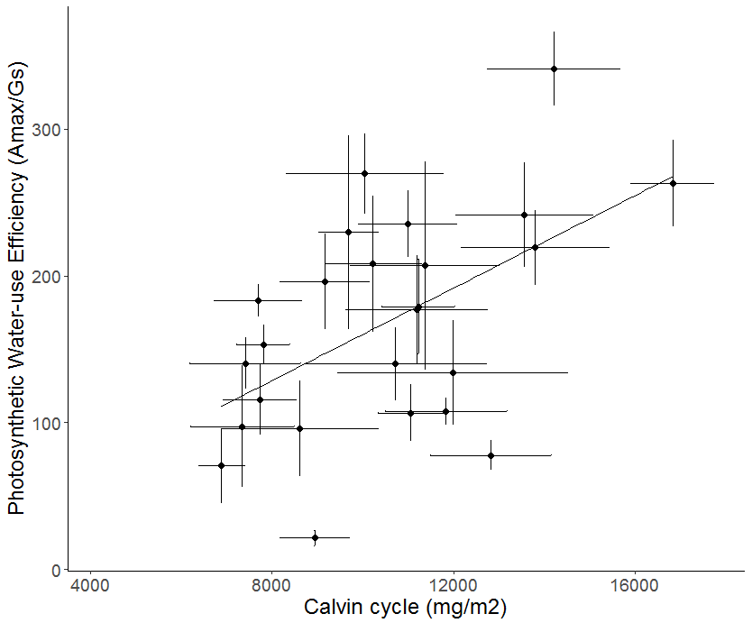

C:\Users\James\Desktop\stuff\PEPMOB\D14\output\figures\20170217\tiff\rbact_per_PGK_mean_vs_tavg_R2-0.256_pval-0.tiff

PGLP\_per\_PRK vs tavg

Rbact per PGK vs tavg

Rbact per PRK vs tavg